

STAREHE GIRLS’ 2025 PREDICTION
POSSIBLE KCSE EXAM
121/1
MATHEMATICS
PAPER 1
TIME: 2½ HOURS

NAME……………………………………………………………………………………….
SCHOOL……………………………………………… SIGN………………………..
INDEX NO……………………………………………. ADM NO……………………
INSTRUCTIONS TO CANDIDATES
a) Write your name and index number in the spaces provided above.
b) Sign and write the date of examination in the spaces provided.
c) This paper consists of TWO sections I and II.
d) Answer ALL questions in section I and any five from section II.
e) All answers and working must be done on the question paper in the spaces provided below each question.
f) Show all the steps in your calculations giving your answers at each stage in the spaces below each question.
g) Marks may be given for correct working even if the answer is wrong.
h) Non-programmable silent electronic calculation and KNEC Mathematical tables may be used.

SECTION I (50 Marks)
Answer all questions in this section in the spaces provided
- Without using tables or calculator, evaluate the following. (3mks)
⁻8 + (⁻13) x 3 – (⁻5)
⁻1 + (⁻6) ÷ 2 x 2

2. The straight line through the points D (6, 3) and E (3, -2) meets the y – axis at point F. Find the co-ordinates of F. (3 mks)

3. The circle below whose area is 18.05cm² circumscribes a triangle ABC where AB = 6.3cm,BC = 5.7cm and AC = 4.2cm. Find the area of the shaded part to 2 dp. (3 mks)
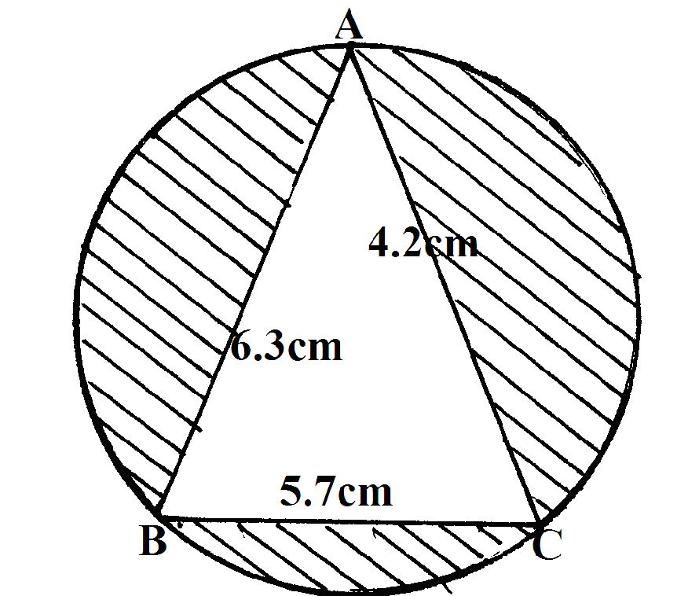

4. A number n is such that when it is divided by 27, 30, or 45, the remainder is always 3. Find the smallest value of n. (3 mks)

5. The actual area of an estate is 3510 hectares. The estate is represented by a rectangle measuring 2.6cm by 1.5cm on the map whose scale is l: n. Find the value of n. (give your answer in standard form) (3 mks)

6. Find the obtuse angle the line y – 2x = 7 makes with the x – axis (2 mks)

7. Given the column vector
(i) Express as a column vector (2mks)

(ii) Calculate the magnitude of vector in (i) above correct to two decimal places. (2mks)

8. Muthoni went to a shop and bought 50 packets of milk and 25 packets of salt all for Kshs.200.00. She sold the milk at a profit of 28% and the salt at a profit of 24% thereby making a net profit of Kshs.53.50. Find the cost price of a packet of milk and a packet of salt. (3 mks)

9. The angles of elevation from two points A and B to the top of a storey building are 48⁰ and 57⁰ respectively. If AB = 50m and the point A and B are opposite each other; Calculate;
a) The distance of point A to the building (3 mks)

b) The height of the building (1 mks)

10. Find x if 3^{2x+3} + 1 = 28 (2 mks)

11. Simplify as simple as possible (3 mks)

12. The cost of a camera outside Kenya is US$1000. James intends to buy one camera through an agent who deals in Japanese Yen. The agent charges him a commission of 5% on the price of the camera and further 1260 Yen as importation tax. How much in Ksh. Will he need to send to the agent to obtain the camera, given that:- (3 mks)
1 US$= 105.00 Yen. 1 US$= Kshs.63.00

13. State all the integral values of x which satisfy the inequality
(3mks)

14. Without using a protractor, construct a triangle ABC such that angle ABC = 135⁰, AB = 4.6cm and BC =6.1cm. Measure AC and angle ACB 4 mks)

15. Without using mathematical tables or calculators, find the volume of a container whose base is a regular hexagon of side cm and height cm (3 mks)

16. Below is a net of a model of a three dimensional figure. The lengths AB = BC = AC = 6.0cm and lengths AF = FB = BD = CD = CE = AE = 8.0cm. 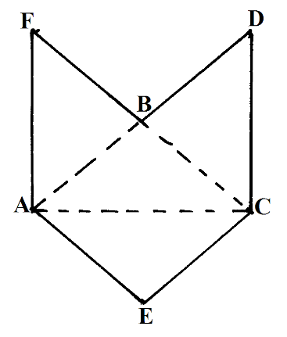
a) Draw the solid when the net is folded by taking ABC as the base and the height 5cm. (3 mks)

b) State the name of the figure drawn ;………………………………………………………. (1 mk)
SECTION II (50 Marks)
Answer only five questions in this section in the spaces provided.
17. The distance between towns A and B is 360km. a minibus left A at 8.15am and traveled towards B at an average speed of 90km/hr. A matatu left B two and a third hours later on the same day and traveled towards A at an average speed of 110km/hr.
a) i) At what time did the two vehicles meet? (4mks)

ii) How far from A did the vehicles meet? (2mks)

b) A motorist started from his home which is between A and B at 10.30am on the same day and travelled at an average speed of 100km/hr. he arrived at B at the same time as the minibus. Calculate the distance from A to his house. (4 mks)

.

18. Consider the vessel below
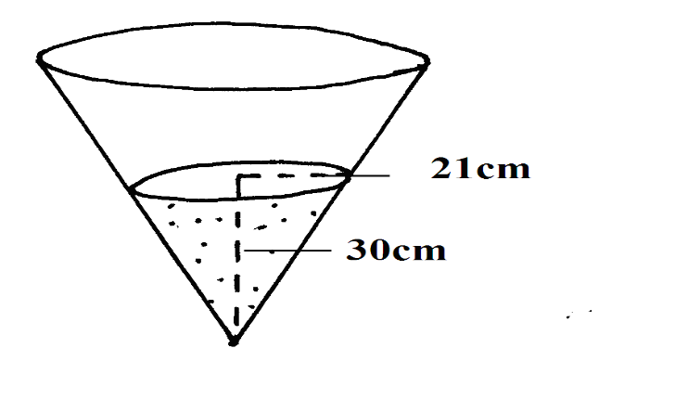
a) Calculate the volume of water in the vessel. (Take π = 3.142) (2mks)

b) When a metallic hemisphere is completely submerged in the water, the level of the water rose by 6cm. Calculate:
i) the radius of the new water surface. (2mks)

ii) the volume of the metallic hemisphere (to 2 d.p.) (3mks)

iii) the diameter of the hemisphere (to 1 d.p) (3 mks)

19.The American government hired two planes to airlift football fans to Qatar for the World cup tournament. Each plane took 10½ hours to reach the destination.
Boeing 747 has carrying capacity of 300 people and consumes fuel at 120 litres per minute. It makes 5 trips at full capacity. Boeing 740 has carrying capacity of 140 people and consumes fuel at 200 liters per minute. It makes 8 trips at full capacity. If the government sponsored the fans one way at a cost of 800 dollars per fan, and the fans pays for the return ticket. Calculate:
(a) The total number of fans airlifted to Qatar. (1mk)

(b) The total cost of fuel used if one litre costs 0.3 dollars. (5mks)

(c) The total collection in dollars made by each plane. (2mks)

(d) The net profit made by each plane. (2mks)

20. The following data shows the length of trees grown in Mau Forest measured to the nearest cm by a research team. Use the given data to answer the given questions.
230 240 250 253 260 253 274 238 263 260 231 284 257 260 275 271 257 267 255 265 241 256 256 257 260 262 234 259 263 244 254 248 281 240 247 236 256 282 242 246 277 238 250 279 252 269 284 271 249 273
(a) Arrange the data in a frequency distribution table with a class interval of five and starting with the class of 230 – 234,… (6mks)

(b) Using the frequency distribution in (a) above and 257 as an assumed mean, find:-
(i) Mean of the data. (2mks)

(ii) The standard deviation of the data. (2mks)

21.Using a ruler and a pair of compasses only, draw a triangle ABC such that AB = 5cm,
BC = 8cm and angle ABC = 60⁰. Measure AC and angle ACB. (5mks)

a) Locate point O in triangle ABC such that OA = OB = OC. Using O as the center and radius OA draw a circle (3mks)
b) Construct a perpendicular from A to BC to meet BC at D. Measure AD, hence find the area of triangle ABC. (2mks)

22.Three brick layers have to lay a total of 5400 bricks . The average number of bricks they can lay in an hour are in the ratio 5:6:9.If the slowest man lays 60 brick in an hour. Calculate;
(a) How many bricks each of the other two men lay in an hour. (4mks)

(b) How many of the bricks each man will lay to complete the work if they are all employed for the same number of hours. (6mks)

23.Four towns P, Q, R and S are such that town Q is 120km due east of town P. Town R is 160km due North of town Q. Town S is on a bearing of 330º from P and on a bearing 300 º from R. use a ruler and a pair of compasses only for all your constructions.
  - Using a scale of 1cm to represent 50km, construct a scale drawing showing the positions P, Q, R and S. (6mks)

.

  - Use the scale to determine
          - The distance from town S to town P. (1mk)
          - The distance from town S to town R. (1mk)
          - The bearing of town S from town Q. (2mks)

24. A carpenter constructed a closed wooden box with internal measurements 1.5m long 0.8m wide and 0.4m high. The wood used in constructing the box was 1.0cm thick and had a density of 0.6g/cm³.
(a) Determine the:
(i) Volume in cm³ of the wood used in constructing the box. (4 mks)

(ii) Mass of the box in kg correct to 1 d.p (2 mks)

(b) Identical cylindrical tins of diameter 10cm height 20cm with a mass of 120g each were packed in the box. Calculate the:
(i) Maximum number of tins that were packed (2 mks)

(ii) Total mass of the box with the tins in kg. (to 1d.p) (2 mks)

THIS IS THE LAST PRINTED PAGE

